Contents

**Screenshots** 2

**Source codes** 5

Figures

Figure 1: Empty input validation 2

Figure 2 : Dictionary word search 3

Figure 3:Sample Terminal console output 4

Figure 4: Dictionary.js 5

Figure 5: dict.html 6

Figure 6: dict.js 7

Figure 7: word.js 8

Figure 8:CSS [ disct.css ] 9

Figure 9:Project structure and package.json 10

**Screenshots**

Figure : Empty input validation

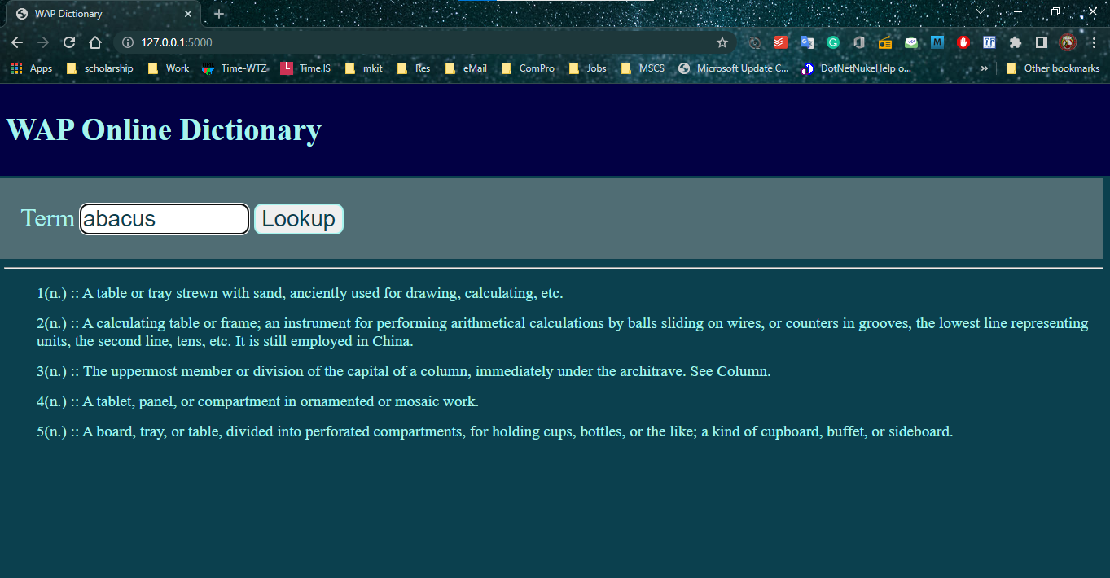

Figure : Dictionary word search

Figure :Sample Terminal console output

# **Source codes**

Figure : Dictionary.js

Figure : dict.html

Figure : dict.js

Figure : word.js

Figure :CSS [ disct.css ]

Figure :Project structure and package.json